9/14/2021

Mc Shane Jack

LYIT

Experiment Portfolio – Craignahorna 3

RIVERS Project

Contents

1. Procedure 3

2. Experiment Apparatus (Insert Pictures When Carried out) 4

3. Time 1 – 11.00am 5

3.1. Experiment 1 5

3.1.1. Plastic Bottle 5

3.1.2. Plastic Bottle 6

3.1.3. Plastic Bottle 7

3.1.4. Plastic Coloured Bottle 8

3.1.5. Plastic Coloured Bottle 9

3.1.6. Plastic Coloured Bottle 10

3.1.7. Plastic Clear Bag 11

3.1.8. Plastic Clear Bag 12

3.1.9. Plastic Clear Bag 13

3.1.10. Plastic Coloured Bag 14

3.1.11. Plastic Coloured Bag 15

3.1.12. Plastic Coloured Bag 16

4. Time 2 – 4.30 pm 17

4.1. Experiment 2 17

4.1.1. Plastic Bottle 17

4.1.2. Plastic Bottle 18

4.1.3. Plastic Bottle 19

4.1.4. Plastic Coloured Bottle 20

4.1.5. Plastic Coloured Bottle 21

4.1.6. Plastic Coloured Bottle 22

4.1.7. Plastic Clear Bag 23

4.1.8. Plastic Clear Bag 24

4.1.9. Plastic Clear Bag 25

4.1.10. Plastic Coloured Bag 26

4.1.11. Plastic Coloured Bag 27

4.1.12. Plastic Coloured Bag 28

5. Time 3 – 9.00pm 29

5.1. Experiment 3 29

5.1.1. Plastic Bottle 29

5.1.2. Plastic Bottle 30

5.1.3. Plastic Bottle 31

5.1.4. Plastic Coloured Bottle 32

5.1.5. Plastic Coloured Bottle 33

5.1.6. Plastic Coloured Bottle 34

5.1.7. Plastic Clear Bag 35

5.1.8. Plastic Clear Bag 36

5.1.9. Plastic Clear Bag 37

5.1.10. Plastic Coloured Bag 38

5.1.11. Plastic Coloured Bag 39

5.1.12. Plastic Coloured Bag 40

# Procedure

* Identify rivers and streams for testing.
* Create test waste objects.
  + Plastic Clear Bottle
  + Plastic Labelled Bottle
  + Clear Plastic Bag
  + Coloured Plastic Bag
  + Tin Can
* When on location, document test information.
* Mark camera area for testing.
* Start camera recording, taking a snapshot of each piece of waste.
* Release waste and collect once it has passed.
* Repeat three times at each location
* Estimated Times*
  + 10.00 am
  + 3.00 pm
  + 7.30 pm

# Experiment Apparatus (Insert Pictures When Carried out)

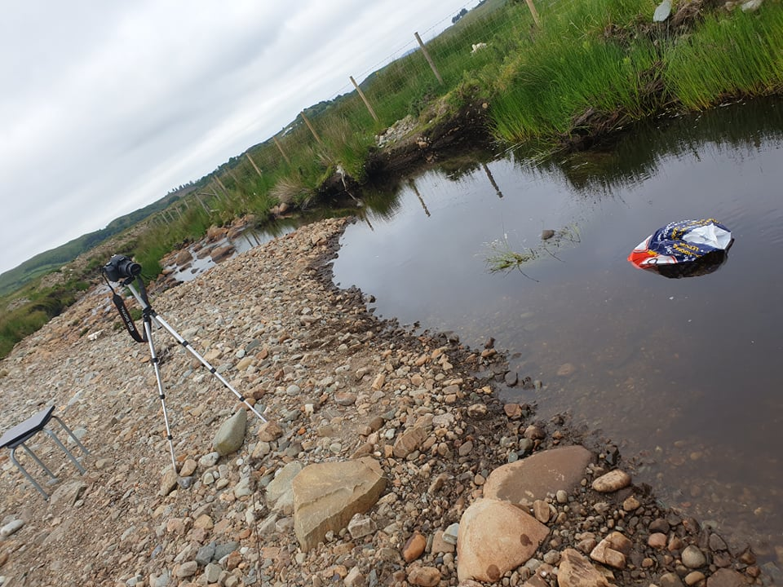

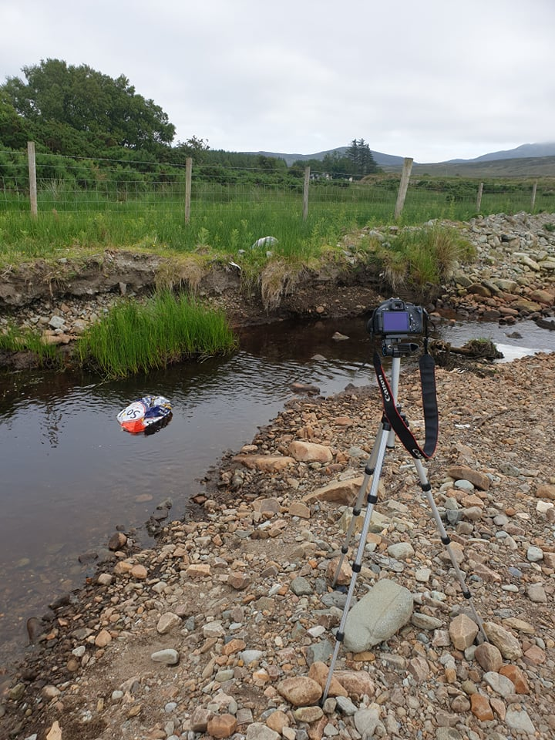

# Time 1 – 11.00am

## Experiment 1

### Plastic Bottle

|  |  |
| --- | --- |
| Name: | Jack McShane |
| Project: | RIVERS: Real-Time Identification of Various Environmental Pollutants in Rivers |
| Test Number: | 1 |

|  |  |
| --- | --- |
| **Test Number** | **1** |
| Weather Conditions | Clear Blue Sky |
| Light Conditions | Bright, FC = 3725 |
| Date | 27/03/2022 |
| Vegetation | Stoney, Mossy |
| Season | Spring |
| Humidity | 66% |
| Time of Day | Morning |
| Wind Speed | 6 km/h |
| Water Speed and Depth | 1 Knot, 1 ft deep |
| Waste Type | Rubbish |
| River Location and Name | Craignahorna |
| Water Clarity | Clear |
| Tidal | Bog Stream |
| Angle of Sun | 110 Degrees E |
| Capture Mode | DSLR |
| Duration | 1 hr |
| River/Stream Width | 2 Metres |
| Temperature | 12 Degrees |

### Plastic Bottle

|  |  |
| --- | --- |
| Name: | Jack McShane |
| Project: | RIVERS: Real-Time Identification of Various Environmental Pollutants in Rivers |
| Test Number: | 2 |

|  |  |
| --- | --- |
| **Test Number** | **2** |
| Weather Conditions | Clear Blue Sky |
| Light Conditions | Bright, FC = 4092 |
| Date | 27/03/2022 |
| Vegetation | Stoney, Mossy |
| Season | Spring |
| Humidity | 66% |
| Time of Day | Morning |
| Wind Speed | 6 km/h |
| Water Speed and Depth | 1 Knot, 1 ft deep |
| Waste Type | Rubbish |
| River Location and Name | Craignahorna |
| Water Clarity | Clear |
| Tidal | Bog Stream |
| Angle of Sun | 110 Degrees E |
| Capture Mode | DSLR |
| Duration | 1 hr |
| River/Stream Width | 2 Metres |
| Temperature | 12 Degrees |

### Plastic Bottle

|  |  |
| --- | --- |
| Name: | Jack McShane |
| Project: | RIVERS: Real-Time Identification of Various Environmental Pollutants in Rivers |
| Test Number: | 3 |

|  |  |
| --- | --- |
| **Test Number** | **3** |
| Weather Conditions | Clear Blue Sky |
| Light Conditions | Bright, FC = 4401 |
| Date | 27/03/2022 |
| Vegetation | Stoney, Mossy |
| Season | Spring |
| Humidity | 66% |
| Time of Day | Morning |
| Wind Speed | 6 km/h |
| Water Speed and Depth | 1 Knot, 1 ft deep |
| Waste Type | Rubbish |
| River Location and Name | Craignahorna |
| Water Clarity | Clear |
| Tidal | Bog Stream |
| Angle of Sun | 110 Degrees E |
| Capture Mode | DSLR |
| Duration | 1 hr |
| River/Stream Width | 2 Metres |
| Temperature | 12 Degrees |

### Plastic Coloured Bottle

|  |  |
| --- | --- |
| Name: | Jack McShane |
| Project: | RIVERS: Real-Time Identification of Various Environmental Pollutants in Rivers |
| Test Number: | 1 |

|  |  |
| --- | --- |
| **Test Number** | **1** |
| Weather Conditions | Clear Blue Sky |
| Light Conditions | Bright, FC = 4536 |
| Date | 27/03/2022 |
| Vegetation | Stoney, Mossy |
| Season | Spring |
| Humidity | 65% |
| Time of Day | Morning |
| Wind Speed | 8 km/h |
| Water Speed and Depth | 1 Knot, 1 ft deep |
| Waste Type | Rubbish |
| River Location and Name | Craignahorna |
| Water Clarity | Clear |
| Tidal | Bog Stream |
| Angle of Sun | 120 Degrees SE |
| Capture Mode | DSLR |
| Duration | 1 hr |
| River/Stream Width | 2 Metres |
| Temperature | 12 Degrees |

### Plastic Coloured Bottle

|  |  |
| --- | --- |
| Name: | Jack McShane |
| Project: | RIVERS: Real-Time Identification of Various Environmental Pollutants in Rivers |
| Test Number: | 2 |

|  |  |
| --- | --- |
| **Test Number** | **2** |
| Weather Conditions | Clear Blue Sky |
| Light Conditions | Bright, FC = 4558 |
| Date | 27/03/2022 |
| Vegetation | Stoney, Mossy |
| Season | Spring |
| Humidity | 65% |
| Time of Day | Morning |
| Wind Speed | 8 km/h |
| Water Speed and Depth | 1 Knot, 1 ft deep |
| Waste Type | Rubbish |
| River Location and Name | Craignahorna |
| Water Clarity | Clear |
| Tidal | Bog Stream |
| Angle of Sun | 128 Degrees SE |
| Capture Mode | DSLR |
| Duration | 1 hr |
| River/Stream Width | 2 Metres |
| Temperature | 12 Degrees |

### Plastic Coloured Bottle

|  |  |
| --- | --- |
| Name: | Jack McShane |
| Project: | RIVERS: Real-Time Identification of Various Environmental Pollutants in Rivers |
| Test Number: | 3 |

|  |  |
| --- | --- |
| **Test Number** | **3** |
| Weather Conditions | Clear Blue Sky |
| Light Conditions | Bright, FC = 4444 |
| Date | 27/03/2022 |
| Vegetation | Stoney, Mossy |
| Season | Spring |
| Humidity | 63% |
| Time of Day | Morning |
| Wind Speed | 8 km/h |
| Water Speed and Depth | 1 Knot, 1 ft deep |
| Waste Type | Rubbish |
| River Location and Name | Craignahorna |
| Water Clarity | Clear |
| Tidal | Bog Stream |
| Angle of Sun | 131 Degrees SE |
| Capture Mode | DSLR |
| Duration | 1 hr |
| River/Stream Width | 2 Metres |
| Temperature | 13 Degrees |

### Plastic Clear Bag

|  |  |
| --- | --- |
| Name: | Jack McShane |
| Project: | RIVERS: Real-Time Identification of Various Environmental Pollutants in Rivers |
| Test Number: | 1 |

|  |  |
| --- | --- |
| **Test Number** | **1** |
| Weather Conditions | Clear Blue Sky |
| Light Conditions | Bright, FC = 4528 |
| Date | 27/03/2022 |
| Vegetation | Stoney, Mossy |
| Season | Spring |
| Humidity | 61% |
| Time of Day | Morning |
| Wind Speed | 10 km/h |
| Water Speed and Depth | 1 Knot, 1 ft deep |
| Waste Type | Rubbish |
| River Location and Name | Craignahorna |
| Water Clarity | Clear |
| Tidal | Bog Stream |
| Angle of Sun | 132 Degrees SE |
| Capture Mode | DSLR |
| Duration | 1 hr |
| River/Stream Width | 2 Metres |
| Temperature | 13 Degrees |

### Plastic Clear Bag

|  |  |
| --- | --- |
| Name: | Jack McShane |
| Project: | RIVERS: Real-Time Identification of Various Environmental Pollutants in Rivers |
| Test Number: | 2 |

|  |  |
| --- | --- |
| **Test Number** | **2** |
| Weather Conditions | Clear Blue Sky |
| Light Conditions | Bright, FC = 4615 |
| Date | 27/03/2022 |
| Vegetation | Stoney, Mossy |
| Season | Spring |
| Humidity | 61% |
| Time of Day | Morning |
| Wind Speed | 10 km/h |
| Water Speed and Depth | 1 Knot, 1 ft deep |
| Waste Type | Rubbish |
| River Location and Name | Craignahorna |
| Water Clarity | Clear |
| Tidal | Bog Stream |
| Angle of Sun | 140 Degrees SE |
| Capture Mode | DSLR |
| Duration | 1 hr |
| River/Stream Width | 2 Metres |
| Temperature | 13 Degrees |

### Plastic Clear Bag

|  |  |
| --- | --- |
| Name: | Jack McShane |
| Project: | RIVERS: Real-Time Identification of Various Environmental Pollutants in Rivers |
| Test Number: | 3 |

|  |  |
| --- | --- |
| **Test Number** | **3** |
| Weather Conditions | Clear Blue Sky |
| Light Conditions | Bright, FC = 4678 |
| Date | 27/03/2022 |
| Vegetation | Stoney, Mossy |
| Season | Spring |
| Humidity | 61% |
| Time of Day | Morning |
| Wind Speed | 10 km/h |
| Water Speed and Depth | 1 Knot, 1 ft deep |
| Waste Type | Rubbish |
| River Location and Name | Craignahorna |
| Water Clarity | Clear |
| Tidal | Bog Stream |
| Angle of Sun | 145 Degrees SE |
| Capture Mode | DSLR |
| Duration | 1 hr |
| River/Stream Width | 2 Metres |
| Temperature | 13 Degrees |

### Plastic Coloured Bag

|  |  |
| --- | --- |
| Name: | Jack McShane |
| Project: | RIVERS: Real-Time Identification of Various Environmental Pollutants in Rivers |
| Test Number: | 1 |

|  |  |
| --- | --- |
| **Test Number** | **1** |
| Weather Conditions | Clear Blue Sky |
| Light Conditions | Bright, FC = 4591 |
| Date | 27/03/2022 |
| Vegetation | Stoney, Mossy |
| Season | Spring |
| Humidity | 61% |
| Time of Day | Morning |
| Wind Speed | 10 km/h |
| Water Speed and Depth | 1 Knot, 1 ft deep |
| Waste Type | Rubbish |
| River Location and Name | Craignahorna |
| Water Clarity | Clear |
| Tidal | Bog Stream |
| Angle of Sun | 146 Degrees SE |
| Capture Mode | DSLR |
| Duration | 1 hr |
| River/Stream Width | 2 Metres |
| Temperature | 13 Degrees |

### Plastic Coloured Bag

|  |  |
| --- | --- |
| Name: | Jack McShane |
| Project: | RIVERS: Real-Time Identification of Various Environmental Pollutants in Rivers |
| Test Number: | 2 |

|  |  |
| --- | --- |
| **Test Number** | **2** |
| Weather Conditions | Clear Blue Sky |
| Light Conditions | Bright, FC = 4611 |
| Date | 27/03/2022 |
| Vegetation | Stoney, Mossy |
| Season | Spring |
| Humidity | 60% |
| Time of Day | Morning |
| Wind Speed | 10 km/h |
| Water Speed and Depth | 1 Knot, 1 ft deep |
| Waste Type | Rubbish |
| River Location and Name | Craignahorna |
| Water Clarity | Clear |
| Tidal | Bog Stream |
| Angle of Sun | 146 Degrees SE |
| Capture Mode | DSLR |
| Duration | 1 hr |
| River/Stream Width | 2 Metres |
| Temperature | 13 Degrees |

### Plastic Coloured Bag

|  |  |
| --- | --- |
| Name: | Jack McShane |
| Project: | RIVERS: Real-Time Identification of Various Environmental Pollutants in Rivers |
| Test Number: | 3 |

|  |  |
| --- | --- |
| **Test Number** | **3** |
| Weather Conditions | Clear Blue Sky |
| Light Conditions | Bright, FC = 4665 |
| Date | 27/03/2022 |
| Vegetation | Stoney, Mossy |
| Season | Spring |
| Humidity | 60% |
| Time of Day | Morning |
| Wind Speed | 10 km/h |
| Water Speed and Depth | 1 Knot, 1 ft deep |
| Waste Type | Rubbish |
| River Location and Name | Craignahorna |
| Water Clarity | Clear |
| Tidal | Bog Stream |
| Angle of Sun | 153 Degrees SE |
| Capture Mode | DSLR |
| Duration | 1 hr |
| River/Stream Width | 2 Metres |
| Temperature | 13 Degrees |

# Time 2 – 4.30 pm

## Experiment 2 000000000000

### Plastic Bottle

|  |  |
| --- | --- |
| Name: | Jack McShane |
| Project: | RIVERS: Real-Time Identification of Various Environmental Pollutants in Rivers |
| Test Number: | 1 |

|  |  |
| --- | --- |
| **Test Number** | **1** |
| Weather Conditions | Overcast |
| Light Conditions | Bright, FC = 2215 |
| Date | 27/03/2022 |
| Vegetation | Stoney, Mossy |
| Season | Spring |
| Humidity | 59% |
| Time of Day | Midday |
| Wind Speed | 13 km/h |
| Water Speed and Depth | 1 Knot, 1 ft deep |
| Waste Type | Rubbish |
| River Location and Name | Craignahorna |
| Water Clarity | Clear |
| Tidal | Bog Stream |
| Angle of Sun | No Sun |
| Capture Mode | DSLR |
| Duration | 1 hr |
| River/Stream Width | 2 Metres |
| Temperature | 15 Degrees |

### Plastic Bottle

|  |  |
| --- | --- |
| Name: | Jack McShane |
| Project: | RIVERS: Real-Time Identification of Various Environmental Pollutants in Rivers |
| Test Number: | 2 |

|  |  |
| --- | --- |
| **Test Number** | **2** |
| Weather Conditions | Overcast |
| Light Conditions | Bright, FC = 1965 |
| Date | 27/03/2022 |
| Vegetation | Stoney, Mossy |
| Season | Spring |
| Humidity | 59% |
| Time of Day | Midday |
| Wind Speed | 13 km/h |
| Water Speed and Depth | 1 Knot, 1 ft deep |
| Waste Type | Rubbish |
| River Location and Name | Craignahorna |
| Water Clarity | Clear |
| Tidal | Bog Stream |
| Angle of Sun | No Sun |
| Capture Mode | DSLR |
| Duration | 1 hr |
| River/Stream Width | 2 Metres |
| Temperature | 15 Degrees |

### Plastic Bottle

|  |  |
| --- | --- |
| Name: | Jack McShane |
| Project: | RIVERS: Real-Time Identification of Various Environmental Pollutants in Rivers |
| Test Number: | 3 |

|  |  |
| --- | --- |
| **Test Number** | **3** |
| Weather Conditions | Overcast |
| Light Conditions | Bright, FC = 1957 |
| Date | 27/03/2022 |
| Vegetation | Stoney, Mossy |
| Season | Spring |
| Humidity | 59% |
| Time of Day | Midday |
| Wind Speed | 13 km/h |
| Water Speed and Depth | 1 Knot, 1 ft deep |
| Waste Type | Rubbish |
| River Location and Name | Craignahorna |
| Water Clarity | Clear |
| Tidal | Bog Stream |
| Angle of Sun | No Sun |
| Capture Mode | DSLR |
| Duration | 1 hr |
| River/Stream Width | 2 Metres |
| Temperature | 15 Degrees |

### Plastic Coloured Bottle

|  |  |
| --- | --- |
| Name: | Jack McShane |
| Project: | RIVERS: Real-Time Identification of Various Environmental Pollutants in Rivers |
| Test Number: | 1 |

|  |  |
| --- | --- |
| **Test Number** | **1** |
| Weather Conditions | Overcast |
| Light Conditions | Bright, FC = 1875 |
| Date | 27/03/2022 |
| Vegetation | Stoney, Mossy |
| Season | Spring |
| Humidity | 59% |
| Time of Day | Midday |
| Wind Speed | 13 km/h |
| Water Speed and Depth | 1 Knot, 1 ft deep |
| Waste Type | Rubbish |
| River Location and Name | Craignahorna |
| Water Clarity | Clear |
| Tidal | Bog Stream |
| Angle of Sun | No Sun |
| Capture Mode | DSLR |
| Duration | 1 hr |
| River/Stream Width | 2 Metres |
| Temperature | 15 Degrees |

### Plastic Coloured Bottle

|  |  |
| --- | --- |
| Name: | Jack McShane |
| Project: | RIVERS: Real-Time Identification of Various Environmental Pollutants in Rivers |
| Test Number: | 2 |

|  |  |
| --- | --- |
| **Test Number** | **2** |
| Weather Conditions | Overcast |
| Light Conditions | Bright, FC = 1763 |
| Date | 27/03/2022 |
| Vegetation | Stoney, Mossy |
| Season | Spring |
| Humidity | 59% |
| Time of Day | Midday |
| Wind Speed | 13 km/h |
| Water Speed and Depth | 1 Knot, 1 ft deep |
| Waste Type | Rubbish |
| River Location and Name | Craignahorna |
| Water Clarity | Clear |
| Tidal | Bog Stream |
| Angle of Sun | No Sun |
| Capture Mode | DSLR |
| Duration | 1 hr |
| River/Stream Width | 2 Metres |
| Temperature | 15 Degrees |

### Plastic Coloured Bottle

|  |  |
| --- | --- |
| Name: | Jack McShane |
| Project: | RIVERS: Real-Time Identification of Various Environmental Pollutants in Rivers |
| Test Number: | 3 |

|  |  |
| --- | --- |
| **Test Number** | **3** |
| Weather Conditions | Overcast |
| Light Conditions | Bright, FC = 1677 |
| Date | 27/03/2022 |
| Vegetation | Stoney, Mossy |
| Season | Spring |
| Humidity | 59% |
| Time of Day | Midday |
| Wind Speed | 13 km/h |
| Water Speed and Depth | 1 Knot, 1 ft deep |
| Waste Type | Rubbish |
| River Location and Name | Craignahorna |
| Water Clarity | Clear |
| Tidal | Bog Stream |
| Angle of Sun | No Sun |
| Capture Mode | DSLR |
| Duration | 1 hr |
| River/Stream Width | 2 Metres |
| Temperature | 15 Degrees |

### Plastic Clear Bag

|  |  |
| --- | --- |
| Name: | Jack McShane |
| Project: | RIVERS: Real-Time Identification of Various Environmental Pollutants in Rivers |
| Test Number: | 1 |

|  |  |
| --- | --- |
| **Test Number** | **1** |
| Weather Conditions | Overcast |
| Light Conditions | Bright, FC = 1580 |
| Date | 27/03/2022 |
| Vegetation | Stoney, Mossy |
| Season | Spring |
| Humidity | 59% |
| Time of Day | Midday |
| Wind Speed | 11 km/h |
| Water Speed and Depth | 1 Knot, 1 ft deep |
| Waste Type | Rubbish |
| River Location and Name | Craignahorna |
| Water Clarity | Clear |
| Tidal | Bog Stream |
| Angle of Sun | No Sun |
| Capture Mode | DSLR |
| Duration | 1 hr |
| River/Stream Width | 2 Metres |
| Temperature | 15 Degrees |

### Plastic Clear Bag

|  |  |
| --- | --- |
| Name: | Jack McShane |
| Project: | RIVERS: Real-Time Identification of Various Environmental Pollutants in Rivers |
| Test Number: | 2 |

|  |  |
| --- | --- |
| **Test Number** | **2** |
| Weather Conditions | Overcast |
| Light Conditions | Bright, FC = 1563 |
| Date | 27/03/2022 |
| Vegetation | Stoney, Mossy |
| Season | Spring |
| Humidity | 59% |
| Time of Day | Midday |
| Wind Speed | 11 km/h |
| Water Speed and Depth | 1 Knot, 1 ft deep |
| Waste Type | Rubbish |
| River Location and Name | Craignahorna |
| Water Clarity | Clear |
| Tidal | Bog Stream |
| Angle of Sun | No Sun |
| Capture Mode | DSLR |
| Duration | 1 hr |
| River/Stream Width | 2 Metres |
| Temperature | 15 Degrees |

### Plastic Clear Bag

|  |  |
| --- | --- |
| Name: | Jack McShane |
| Project: | RIVERS: Real-Time Identification of Various Environmental Pollutants in Rivers |
| Test Number: | 3 |

|  |  |
| --- | --- |
| **Test Number** | **3** |
| Weather Conditions | Overcast |
| Light Conditions | Bright, FC = 1549 |
| Date | 27/03/2022 |
| Vegetation | Stoney, Mossy |
| Season | Spring |
| Humidity | 59% |
| Time of Day | Midday |
| Wind Speed | 11 km/h |
| Water Speed and Depth | 1 Knot, 1 ft deep |
| Waste Type | Rubbish |
| River Location and Name | Craignahorna |
| Water Clarity | Clear |
| Tidal | Bog Stream |
| Angle of Sun | No Sun |
| Capture Mode | DSLR |
| Duration | 1 hr |
| River/Stream Width | 2 Metres |
| Temperature | 15 Degrees |

### Plastic Coloured Bag

|  |  |
| --- | --- |
| Name: | Jack McShane |
| Project: | RIVERS: Real-Time Identification of Various Environmental Pollutants in Rivers |
| Test Number: | 1 |

|  |  |
| --- | --- |
| **Test Number** | **1** |
| Weather Conditions | Overcast |
| Light Conditions | Bright, FC = 1524 |
| Date | 27/03/2022 |
| Vegetation | Stoney, Mossy |
| Season | Spring |
| Humidity | 59% |
| Time of Day | Midday |
| Wind Speed | 11 km/h |
| Water Speed and Depth | 1 Knot, 1 ft deep |
| Waste Type | Rubbish |
| River Location and Name | Craignahorna |
| Water Clarity | Clear |
| Tidal | Bog Stream |
| Angle of Sun | No Sun |
| Capture Mode | DSLR |
| Duration | 1 hr |
| River/Stream Width | 2 Metres |
| Temperature | 15 Degrees |

### Plastic Coloured Bag

|  |  |
| --- | --- |
| Name: | Jack McShane |
| Project: | RIVERS: Real-Time Identification of Various Environmental Pollutants in Rivers |
| Test Number: | 2 |

|  |  |
| --- | --- |
| **Test Number** | **2** |
| Weather Conditions | Overcast |
| Light Conditions | Bright, FC = 1473 |
| Date | 27/03/2022 |
| Vegetation | Stoney, Mossy |
| Season | Spring |
| Humidity | 59% |
| Time of Day | Midday |
| Wind Speed | 11 km/h |
| Water Speed and Depth | 1 Knot, 1 ft deep |
| Waste Type | Rubbish |
| River Location and Name | Craignahorna |
| Water Clarity | Clear |
| Tidal | Bog Stream |
| Angle of Sun | No Sun |
| Capture Mode | DSLR |
| Duration | 1 hr |
| River/Stream Width | 2 Metres |
| Temperature | 15 Degrees |

### Plastic Coloured Bag

|  |  |
| --- | --- |
| Name: | Jack McShane |
| Project: | RIVERS: Real-Time Identification of Various Environmental Pollutants in Rivers |
| Test Number: | 3 |

|  |  |
| --- | --- |
| **Test Number** | **3** |
| Weather Conditions | Overcast |
| Light Conditions | Bright, FC = 1469 |
| Date | 27/03/2022 |
| Vegetation | Stoney, Mossy |
| Season | Spring |
| Humidity | 59% |
| Time of Day | Midday |
| Wind Speed | 11 km/h |
| Water Speed and Depth | 1 Knot, 1 ft deep |
| Waste Type | Rubbish |
| River Location and Name | Craignahorna |
| Water Clarity | Clear |
| Tidal | Bog Stream |
| Angle of Sun | No Sun |
| Capture Mode | DSLR |
| Duration | 1 hr |
| River/Stream Width | 2 Metres |
| Temperature | 15 Degrees |

# Time 3 – 9.30pm

## Experiment 3

### Plastic Bottle

|  |  |
| --- | --- |
| Name: | Jack McShane |
| Project: | RIVERS: Real-Time Identification of Various Environmental Pollutants in Rivers |
| Test Number: | 1 |

|  |  |
| --- | --- |
| **Test Number** | **1** |
| Weather Conditions | Clear Blue Sky |
| Light Conditions | Dull, FC = 34.9 |
| Date | 14/09/2021 |
| Vegetation | Stoney and mossy |
| Season | Summer |
| Humidity | 77% |
| Time of Day | 9.50pm |
| Wind Speed | 13 km/h |
| Water Speed and Depth | 1knt, 1 foot deep |
| Waste Type | Rubbish |
| River Location and Name | Craignahorna |
| Water Clarity | Clear |
| Tidal | Bog Stream |
| Angle of Sun | 315 degrees nw |
| Capture Mode | DSLR |
| Duration | 1 hr |
| River/Stream Width | 2 Metres |
| Temperature | 17 degrees |

### Plastic Bottle

|  |  |
| --- | --- |
| Name: | Jack McShane |
| Project: | RIVERS: Real-Time Identification of Various Environmental Pollutants in Rivers |
| Test Number: | 2 |

|  |  |
| --- | --- |
| **Test Number** | **2** |
| Weather Conditions | Clear Blue Sky |
| Light Conditions | Dull, FC = 33.5 |
| Date | 14/09/2021 |
| Vegetation | Stoney and mossy |
| Season | Summer |
| Humidity | 77% |
| Time of Day | 9.52pm |
| Wind Speed | 13 km/h |
| Water Speed and Depth | 1knt, 1 ft |
| Waste Type | Rubbish |
| River Location and Name | Craignahorna |
| Water Clarity | Clear |
| Tidal | Bog Stream |
| Angle of Sun | 315 degrees nw |
| Capture Mode | DSLR |
| Duration | 1 hr |
| River/Stream Width | 2 metres |
| Temperature | 17 degrees |

### Plastic Bottle

|  |  |
| --- | --- |
| Name: | Jack McShane |
| Project: | RIVERS: Real-Time Identification of Various Environmental Pollutants in Rivers |
| Test Number: | 3 |

|  |  |
| --- | --- |
| **Test Number** | **3** |
| Weather Conditions | Clear Blue Sky |
| Light Conditions | Dull, FC = 31 |
| Date | 14/09/2021 |
| Vegetation | Stoney and mossy |
| Season | Summer |
| Humidity | 77% |
| Time of Day | 9.52pm |
| Wind Speed | 13km/h |
| Water Speed and Depth | 1 knt, 1ft |
| Waste Type | Rubbish |
| River Location and Name | Craignahorna |
| Water Clarity | Clear |
| Tidal | Bog Stream |
| Angle of Sun | 315 degrees nw |
| Capture Mode | DSLR |
| Duration | 1 hr |
| River/Stream Width | 2 metres |
| Temperature | 17 degrees |

### Plastic Coloured Bottle

|  |  |
| --- | --- |
| Name: | Jack McShane |
| Project: | RIVERS: Real-Time Identification of Various Environmental Pollutants in Rivers |
| Test Number: | 1 |

|  |  |
| --- | --- |
| **Test Number** | **1** |
| Weather Conditions | Overcast, cloudy |
| Light Conditions | Dull, FC = 28.1 |
| Date | 14/09/2021 |
| Vegetation | Stoney and mossy |
| Season | Summer |
| Humidity | 77% |
| Time of Day | 9.54 pm |
| Wind Speed | 8 km/h |
| Water Speed and Depth | 1knt, 1ft |
| Waste Type | Rubbish |
| River Location and Name | Craignahorna |
| Water Clarity | Clear |
| Tidal | Bog Stream |
| Angle of Sun | 315 degrees nw |
| Capture Mode | DSLR |
| Duration | 1 hr |
| River/Stream Width | 2 metres |
| Temperature | 17 degrees |

### Plastic Coloured Bottle

|  |  |
| --- | --- |
| Name: | Jack McShane |
| Project: | RIVERS: Real-Time Identification of Various Environmental Pollutants in Rivers |
| Test Number: | 2 |

|  |  |
| --- | --- |
| **Test Number** | **2** |
| Weather Conditions | Clear Blue Sky |
| Light Conditions | Dull, FC = 27.6 |
| Date | 14/09/2021 |
| Vegetation | Stoney and mossy |
| Season | Summer |
| Humidity | 77% |
| Time of Day | 9.55pm |
| Wind Speed | 13km/h |
| Water Speed and Depth | 1knt, 1ft |
| Waste Type | Rubbish |
| River Location and Name | Craignahorna |
| Water Clarity | Clear |
| Tidal | Bog Stream |
| Angle of Sun | 315 degrees nw |
| Capture Mode | DSLR |
| Duration | 1 hr |
| River/Stream Width | 2 metres |
| Temperature | 17 degrees |

### Plastic Coloured Bottle

|  |  |
| --- | --- |
| Name: | Jack McShane |
| Project: | RIVERS: Real-Time Identification of Various Environmental Pollutants in Rivers |
| Test Number: | 3 |

|  |  |
| --- | --- |
| **Test Number** | **3** |
| Weather Conditions | Clear Blue Sky |
| Light Conditions | Dull, FC = 26.2 |
| Date | 14/09/2021 |
| Vegetation | Stoney and mossy |
| Season | Summer |
| Humidity | 77% |
| Time of Day | 9.56 pm |
| Wind Speed | 13km/h |
| Water Speed and Depth | 1knt, 1ft |
| Waste Type | Rubbish |
| River Location and Name | Craignahorna |
| Water Clarity | Clear |
| Tidal | Bog Stream |
| Angle of Sun | 315 degrees nw |
| Capture Mode | DSLR |
| Duration | 1 hr |
| River/Stream Width | 2 metres |
| Temperature | 17 degrees |

### Plastic Clear Bag

|  |  |
| --- | --- |
| Name: | Jack McShane |
| Project: | RIVERS: Real-Time Identification of Various Environmental Pollutants in Rivers |
| Test Number: | 1 |

|  |  |
| --- | --- |
| **Test Number** | **1** |
| Weather Conditions | Clear Blue Sky |
| Light Conditions | Dull, FC= 23.4 |
| Date | 14/09/2021 |
| Vegetation | Stoney and mossy |
| Season | Summer |
| Humidity | 77% |
| Time of Day | 9.58pm |
| Wind Speed | 13km/h |
| Water Speed and Depth | 1knt, 1ft |
| Waste Type | Rubbish |
| River Location and Name | Craignahorna |
| Water Clarity | Clear |
| Tidal | Bog Stream |
| Angle of Sun | 315 degrees nw |
| Capture Mode | DSLR |
| Duration | 1 hr |
| River/Stream Width | 2 metres |
| Temperature | 17 degrees |

### Plastic Clear Bag

|  |  |
| --- | --- |
| Name: | Jack McShane |
| Project: | RIVERS: Real-Time Identification of Various Environmental Pollutants in Rivers |
| Test Number: | 2 |

|  |  |
| --- | --- |
| **Test Number** | **2** |
| Weather Conditions | Clear Blue Sky |
| Light Conditions | Dull, FC = 22.7 |
| Date | 14/09/2021 |
| Vegetation | Stoney and mossy |
| Season | Summer |
| Humidity | 77% |
| Time of Day | 9.59 pm |
| Wind Speed | 13 km/h |
| Water Speed and Depth | 1knt, 1ft |
| Waste Type | Rubbish |
| River Location and Name | Craignahorna |
| Water Clarity | Clear |
| Tidal | Bog Stream |
| Angle of Sun | 315 degrees nw |
| Capture Mode | DSLR |
| Duration | 1 hr |
| River/Stream Width | 2 metres |
| Temperature | 17 degrees |

### Plastic Clear Bag

|  |  |
| --- | --- |
| Name: | Jack McShane |
| Project: | RIVERS: Real-Time Identification of Various Environmental Pollutants in Rivers |
| Test Number: | 3 |

|  |  |
| --- | --- |
| **Test Number** | **3** |
| Weather Conditions | Clear Blue Sky |
| Light Conditions | Dull, FC = 22.1 |
| Date | 14/09/2021 |
| Vegetation | Stoney and mossy |
| Season | Summer |
| Humidity | 77% |
| Time of Day | 10.00pm |
| Wind Speed | 13 km/h |
| Water Speed and Depth | 1knt, 1 ft |
| Waste Type | Rubbish |
| River Location and Name | Craignahorna |
| Water Clarity | Clear |
| Tidal | Bog Stream |
| Angle of Sun | 315 degrees nw |
| Capture Mode | DSLR |
| Duration | 1 hr |
| River/Stream Width | 2 metres |
| Temperature | 17 degrees |

### Plastic Coloured Bag

|  |  |
| --- | --- |
| Name: | Jack McShane |
| Project: | RIVERS: Real-Time Identification of Various Environmental Pollutants in Rivers |
| Test Number: | 1 |

|  |  |
| --- | --- |
| **Test Number** | **1** |
| Weather Conditions | Clear Blue Sky |
| Light Conditions | Dull, FC = 19.6 |
| Date | 14/09/2021 |
| Vegetation | Stoney and mossy |
| Season | Summer |
| Humidity | 77% |
| Time of Day | 10.01 pm |
| Wind Speed | 13km/h |
| Water Speed and Depth | 1knt, 1ft |
| Waste Type | Rubbish |
| River Location and Name | Craignahorna |
| Water Clarity | Clear |
| Tidal | Bog Stream |
| Angle of Sun | 315 degrees nw |
| Capture Mode | DSLR |
| Duration | 1 hr |
| River/Stream Width | 2 metres |
| Temperature | 17 degrees |

### Plastic Coloured Bag

|  |  |
| --- | --- |
| Name: | Jack McShane |
| Project: | RIVERS: Real-Time Identification of Various Environmental Pollutants in Rivers |
| Test Number: | 2 |

|  |  |
| --- | --- |
| **Test Number** | **2** |
| Weather Conditions | Clear Blue Sky |
| Light Conditions | Dull, FC = 18.2 |
| Date | 14/09/2021 |
| Vegetation | Stoney and mossy |
| Season | Summer |
| Humidity | 77% |
| Time of Day | 10.02pm |
| Wind Speed | 13 km/h |
| Water Speed and Depth | 1knt, 1ft |
| Waste Type | Rubbish |
| River Location and Name | Craignahorna |
| Water Clarity | Clear |
| Tidal | Bog Stream |
| Angle of Sun | 315 degrees nw |
| Capture Mode | DSLR |
| Duration | 1 hr |
| River/Stream Width | 2 metres |
| Temperature | 17 degrees |

### Plastic Coloured Bag

|  |  |
| --- | --- |
| Name: | Jack McShane |
| Project: | RIVERS: Real-Time Identification of Various Environmental Pollutants in Rivers |
| Test Number: | 3 |

|  |  |
| --- | --- |
| **Test Number** | **3** |
| Weather Conditions | Clear Blue Sky |
| Light Conditions | Dull, FC = 16.9 |
| Date | 14/09/2021 |
| Vegetation | Stoney and mossy |
| Season | Summer |
| Humidity | 77% |
| Time of Day | 10.05pm |
| Wind Speed | 13 km/h |
| Water Speed and Depth | 1knt, 1ft |
| Waste Type | Rubbish |
| River Location and Name | Craignahorna |
| Water Clarity | Clear |
| Tidal | Bog Stream |
| Angle of Sun | 315 degrees nw |
| Capture Mode | DSLR |
| Duration | 1 hr |
| River/Stream Width | 2 metres |
| Temperature | 17 degrees |